# Lab 5 RIPv1 Configuration

## Topology Diagram

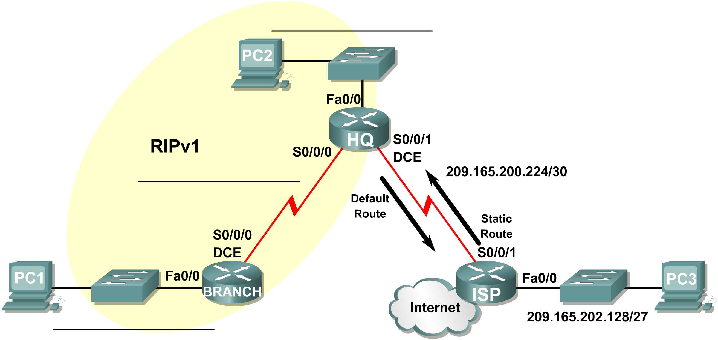

## Addressing Table

|  |  |  |  |  |
| --- | --- | --- | --- | --- |
| **Device** | **Interface** | **IP Address** | **Subnet Mask** | **Default Gateway** |
| BRANCH | Fa0/0 | 10.10.2.1 | 255.255.254.0 | N/A |
| S0/0/0 | 192.168.1.126 | 255.255.255.192 | N/A |
| HQ | Fa0/0 | 192.168.1.129 | 255.255.255.192 | N/A |
| S0/0/0 | 192.168.1.65 | 255.255.255.192 | N/A |
| S0/0/1 | 209.165.200.226 | 255.255.255.252 | N/A |
| ISP | Fa0/0 | 209.165.202.129 | 255.255.255.224 | N/A |
| S0/0/1 | 209.165.200.225 | 255.255.255.252 | N/A |
| PC1 | NIC | 10.10.3.254 | 255.255.254.0 | 10.10.2.1 |
| PC2 | NIC | 192.168.1.190 | 255.255.255.192 | **192.168.1.129** |
| PC3 | NIC | **209.165.202.158** | 255.255.255.224 | 209.165.202.129 |

## Learning Objectives

Upon completion of this lab, you will be able to:

* Subnet an address space given requirements.
* Assign appropriate addresses to interfaces and document them in the Addressing Table.
* Cable a network according to the Topology Diagram.
* Configure RIPv1 routing on routers HQ and BRANCH only.
* Configure and propagate a static default route.
* Verify RIPv1 operation.
* Test and verify full connectivity.

## Scenario

In this lab activity, you are given a network address that must be subnetted to complete the addressing of the network shown in the Topology Diagram. A combination of RIPv1 and static routing will be required so that hosts on networks that are not directly connected will be able to communicate with each other.

Task 1: Subnet the Address Space.

Step 1: Examine the network requirements.

The addressing for the network has the following requirements:

* The ISP LAN will use the 209.165.202.128/27 network.
* The link between the ISP router and the HQ router will use the 209.165.200.224/30 network.
* The 192.168.1.0/24 network must be subnetted for use in the HQ LAN and the link between the HQ and BRANCH routers. The HQ LAN will require 50 host IP addresses.
* The BRANCH LAN will use the 10.10.2.0/23 network.

(**Note:** Remember that the interfaces of network devices are also host IP addresses and are included in the above addressing requirements.)

Step 2: Consider the following questions when creating your network design:

Subnet the 192.168.1.0/24 pool of IP addresses into 4 blocks of 64 IP addresses.

What is the subnet mask for this network in dotted decimal format? 255.255.255.0

What is the subnet mask for the network in slash (CIDR) format? /24

What are the network addresses of the subnets?

Subnet 0: 192.168.1.0

Subnet 1: 192.168.1.64

Subnet 2: 192.168.1.128

Subnet 3: 192.168.1.192

How many usable host IP addresses are there per subnet? 64

How many usable hosts IP addresses are available in the BRANCH LAN? 254

Step 3: Assign subnetwork addresses to the Topology Diagram.

* 1. Assign subnet 1 in the 192.168.1.0 network to the WAN link between the HQ and BRANCH routers.
  2. Assign subnet 2 in the 192.168.1.0 network to the LAN attached to the HQ router.

Task 2: Determine Interface Addresses.

Step 1: Assign appropriate addresses to the device interfaces.

1. Assign the first valid host address in the 209.165.202.128/27 network to the LAN interface on the ISP router.
2. Assign the last valid host address in the 209.165.202.128/27 network to PC3.
3. Assign the first valid host address in the 209.165.200.224/30 network to the WAN interface of the ISP router.
4. Assign the last valid host address in the 209.165.200.224/30 network to the Serial 0/0/1 interface of the HQ router.
5. Assign the first valid host address in the HQ LAN network to the LAN interface of the HQ router.
6. Assign the last valid host address in the HQ LAN network to PC 2.
7. Assign the first valid host address in the HQ/BRANCH WAN link to the Serial 0/0/0 interface of the HQ router.
8. Assign the last valid host address in the HQ/BRANCH WAN link to the Serial 0/0/0 interface of the BRANCH router.
9. Assign the first valid host address in the 10.10.2.0/23 network to the LAN interface on the BRANCH router.
10. Assign the last valid host address in the 10.10.2.0/23 network to PC1.

Step 2: Document the addresses to be used in the table provided under the Topology Diagram.

Task 3: Prepare the Network.

Step 1: Cable a network that is similar to the one in the Topology Diagram.

You can use any 1851 routers – add a WIC – 2T module for the serial ports.

Task 4: Perform Basic Router Configurations.

Perform basic configuration in the BRANCH, HQ, and ISP routers according to the following guidelines:

1. Configure the router hostname.
2. Disable DNS lookup.
3. Configure an EXEC mode password.
4. Configure a message-of-the-day banner.
5. Configure a password for console connections.
6. Configure a password for VTY connections.
7. Synchronize unsolicited messages and debug output with solicited output and prompts for the console and virtual terminal lines.

Task 5: Configure and Activate Serial and Ethernet Addresses.

Step 1: Configure the BRANCH, HQ, and ISP routers.

Configure the interfaces on the BRANCH, HQ, and ISP routers with the IP addresses from the Addressing Table provided under the Topology Diagram.

When you have finished, be sure to save the running configuration to the NVRAM of the router.

Step 2: Configure the Ethernet interfaces of PC1, PC2, and PC3.

Configure the Ethernet interfaces of PC1, PC2, and PC3 with the IP addresses from the Addressing Table provided under the Topology Diagram.

Task 6: Verify Connectivity to Next-Hop Device.

You should *not* have connectivity between end devices yet. However, you can test connectivity between two routers and between an end device and its default gateway.

Step 1: Verify BRANCH connectivity.

Verify that BRANCH can ping across the WAN link to HQ and that HQ can ping across the WAN link it shares with ISP.

Step 2: Verify Ethernet interface connectivity.

Verify that PC1, PC2, and PC3 can ping their respective default gateways.

Task 7: Configure RIP Routing on the BRANCH Router.

Consider the networks that need to be included in the RIP updates that are sent out by the BRANCH router.

What networks are currently present in the BRANCH routing table before RIP is configured? List the networks with slash notation.

192.168.1.0/26

10.0.0.0/23

What commands are required to enable RIP version 1 and include these networks in the routing updates?

conf t

router rip

ver 1

network 192.168.1.0

network 10.0.0.0

Are there any router interfaces that do not need to have RIP updates sent out? Fa0/0

What command is used to disable RIP updates on this interface?

passive-interface Fa0/0

Task 8: Configure RIP and Static Routing on the HQ Router

Consider the type of static routing that is needed on HQ.

What networks are present in the HQ routing table? List the networks with slash notation.

209.165.200.0/30

192.168.1.0/26

A static default route will need to be configured to send all packets with destination addresses that are not in the routing table to the ISP router. What command is needed to accomplish this? Use the appropriate exit interface on the HQ router in the command.

ip route 0.0.0.0 0.0.0.0 S0/0/1

What commands are required to enable RIPv1 and include the LAN network in the routing updates?

conf t

router rip

ver 1

network 192.168.1.0

network 209.165.200.0

Are there any router interfaces that do not need to have RIP updates sent out? Fa0/0

What command is used to disable RIP updates on this interface?

passive-interface Fa0/0

The HQ router needs to send the default route information to the BRANCH router in the RIP updates. What command is used to configure this?

default-information originate

Task 9: Configure Static Routing on the ISP Router

Static routes will need to be configured on the ISP router for all traffic that is destined for networks that are 1] the BRANCH LAN, 2] the HQ LAN, and 3] the WAN network between the BRANCH and HQ routers.

Use a summarized route for the 192.168.1.x subnets – i.e. a single ‘umbrella’ route that covers all subnet addresses. Once the data packet arrives at HQ then HQ decides to which subnet the data packet is sent.

What are the commands that will need to be configured on the ISP router to accomplish this?

ISP(config)# ip route 192.168.1.0 255.255.255.0 Serial0/0/1

ISP(config)# ip route 10.10.2.0 255.255.254.0 Serial0/0/1

Task 10: Verify the Configurations

Answer the following questions to verify that the network is operating as expected.

From PC2, is it possible to ping PC1? Yes

From PC2, is it possible to ping PC3? Yes

From PC1, is it possible to ping PC3? Yes

The answer to the above questions should be **yes**. If any of the above pings failed, check your physical connections and configurations.

What routes are present in the routing table of the BRANCH router?

10.0.0.0/23 is subnetted, 1 subnets

C 10.10.2.0 is directly connected, FastEthernet0/0

192.168.1.0/26 is subnetted, 2 subnets

C 192.168.1.64 is directly connected, Serial0/0/0

R 192.168.1.128 [120/1] via 192.168.1.65, 00:00:05, Serial0/0/0

R 209.165.200.0/24 [120/1] via 192.168.1.65, 00:00:05, Serial0/0/0

R* 0.0.0.0/0 [120/1] via 192.168.1.65, 00:00:05, Serial0/0/0

What is the gateway of last resort in the routing table of the BRANCH router?

192.168.1.65 to network 0.0.0.0

What routes are present in the routing table of the HQ router?

R 10.0.0.0/8 [120/1] via 192.168.1.126, 00:00:08, Serial0/0/0

192.168.1.0/26 is subnetted, 2 subnets

C 192.168.1.64 is directly connected, Serial0/0/0

C 192.168.1.128 is directly connected, FastEthernet0/0

209.165.200.0/30 is subnetted, 1 subnets

C 209.165.200.224 is directly connected, Serial0/0/1

S* 0.0.0.0/0 is directly connected, Serial0/0/1

What networks are present in the routing table of the ISP router?

10.0.0.0/23 is subnetted, 1 subnets

S 10.10.2.0 is directly connected, Serial0/0/1

S 192.168.1.0/24 is directly connected, Serial0/0/1

209.165.200.0/30 is subnetted, 1 subnets

C 209.165.200.224 is directly connected, Serial0/0/1

209.165.202.0/27 is subnetted, 1 subnets

C 209.165.202.128 is directly connected, FastEthernet0/0

What networks, including the metric, are present in the RIP updates sent from the HQ router?

R 10.0.0.0/8 [120/1] via 192.168.1.126, 00:00:08, Serial0/0/0

209.165.200.0

192.168.1.0

What networks, including the metric, are present in the RIP updates sent from the BRANCH router?

R 192.168.1.128 [120/1] via 192.168.1.65, 00:00:05, Serial0/0/0

R 209.165.200.0/24 [120/1] via 192.168.1.65, 00:00:05, Serial0/0/0

R* 0.0.0.0/0 [120/1] via 192.168.1.65, 00:00:05, Serial0/0/0

network 10.0.0.0

network 192.168.1.0

What is the Administrative Distance (AD) associated with the Directly Connected, Static and RIP learned routes in the routing tables?

If static routing were used instead of RIP on the BRANCH router, how many individual static routes would be needed for hosts on the BRANCH LAN to communicate with all of the networks in the Topology Diagram? ______________